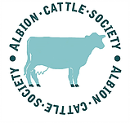
Contact: Secretary: srmannerings@gmail.com 07733 419685 or via Albion Cattle Society website.
Chilton Farm, Alkham, Dover, Kent. CT15 7DR

Minutes of the Albion Cattle Society committee meeting held by conference call, 21st December, 2018.
What action to take now that Albion cattle have been recognised as a native breed by RBST.
Present at the meeting: Susannah Mannerings (Secretary), Ruth Dalton (RBST), John Pring; with John Ball, Lynn Parks and Colin Nankervis consulted after.
New contacts/ members. We have received approximately a dozen serious enquiries since the increased media about Albions, particularly the RBST & Countryfile coverage. All are now on the contact list to be kept up-to-date- it has to be long term interest due to low availability of Albions at present.
Albions for sale. There are not many/any females for sale but there are 3 or 4 yearling bulls available. We would like to know if any are for sale/wanted or even for loan; please use above contact details with information.
Embryo work. Ruth confirmed that RBST will cover the costs of one Albion cow to have oocytes harvested for embryos, which is fantastic news! It would be preferable to select a cow from a rare line; therefore, it was decided to approach H. Friend & I. Fawcett first. RBST would also be able to release a straw of R Blue Mink to fertilise the eggs which is no longer available to buy; this would create a new family line.
AI work. ACS have very kindly been donated some money which is especially for the collection of semen. We have 2 suitable bulls at present, Speckles Ferdinand and Betchton Harold. On-farm collection would be fine as we don’t intend to sell semen abroad. Susannah will contact Venton Stud to discuss costs and conditions.
FAnGR acceptance of Albions on to their Native Breeds at Risk (NBAR) list (for Natural England and future subsidy schemes, disease protection) – Ruth is to find out date of next meeting & Susannah to write letter of request ready for next meeting. (There is no form.)
Zootechnical Legislation application – EU legislation with possible implications for claiming subsidy in future schemes. This form has recently changed; Susannah to e-mail and request form, then apply.
Any other business. Even though there appear to be approx. 160 Albion females according to BCMS, Ruth explained how RBST calculate cattle breed numbers: -
The average heifer calves per year registered over the last 3 years x 4 This low figure is classed as ‘critical’; it is very important to let us know about any heifer calves born and not yet registered as each calf increases the population! Ruth is sending in registrations for 2018.
Susannah will contact Grassroots to update pedigree certificate layout and address.
It was discussed that we would like the 2019 open ACS weekend to be held at Cotswold Farm Park. Ruth suggested that it coincided with the weekend when RBST are there. We will talk with Mike Caunter.
John P suggested that ACS hold quarterly meetings; one at the open weekend & 3 conference calls, to keep things moving forwards.
John P discussed more ways to raise funds for ACS. He himself maybe willing to run a sponsored marathon! Mike C aims to make ACS Cotswold Farm Park’s nominated charity for 2019. Sponsorship plus any grants were suggested along with donations. Also, Susannah will look into on-line crowd funding. Please get in touch if you can help with ideas for this.

CHECK LIST!!
Would you like to join ACS? Is your annual Subscription due? – Subscription £15 (Voluntary donations welcome!)
Please send cheques to: Ms Lynn Parks, (treasurer) Lynn House Farm, Betchton, Sandbach, Cheshire.
CW11 2TX
Are all of your Albions registered? – particularly females. Contact, see letter heading, to update us- very important for population calculations.
Do you have any Albions for sale? – We have had many enquiries so please contact ACS, see letter heading, as a matter of urgency.
Do you wish to purchase Albions?- Due to the small current population, possibilities are limited but will slowly increase with semen and embryo work being done. We hope you realise that this is long term and not immediate. There are young Albion bulls available now to buy:-
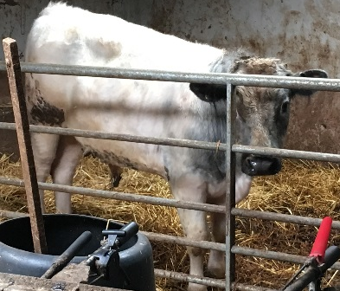
For sale in Cheshire: Speckles Iceman (Blue roan) (Feb 18) by Sp Jake, out of Sp White Joanna (very milky line) Tel: 07594 216744
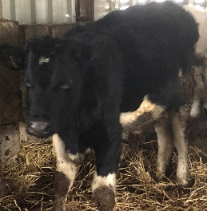

For sale in Derbyshire: Wesley of Leam and Theodore of Leam (Both black, May 18, by SB Hector, out of SB dams.) Tel: 01433 650891/421
For sale in Kent: 2 Albion steers with a cracking bull calf available later on. Tel: 07733 419685
See below:- For sale in W Yorkshire: Tel: 01535 661993
Far Laithe Abel (May 18) Far Laithe Adam (Jun 18)
By R Boy Blue, out of SB Eyebright By SB Hector, out of SB Comfort

